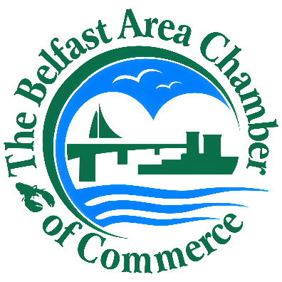


2027
Advertising Kit

Belfast Area Chamber
Regional Guide

Available to Belfast Area
Chamber Members

Help us tell the story about why Belfast & Waldo County is such a great place to live, work and play! Be part of the region’s essential cultural and economic guide! This annual publication will have a print run of 25,000+ copies and will be seen by tens of thousands more. It is distributed across the state, New England, and ordered by vacation planners across the country. Its quality and popularity make it a “must have” for businesses, households, and visitors!

Advertisement & Payment Deadline: Monday, Jaunary 4, 2027

Advertising Options 2027

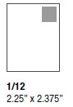  1/12th  Page | A very popular and affordable ad! Your chance to be seen by thousands!  Size: 2.25” x 2.375” | $410
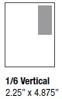  1/6th  Page  Vert. | Get some attention with this practical format! Include a logo and short description of your business!  Size: 2.25” x 4.875” | $725
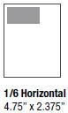  1/6th  Page  Horiz. | Another very popular format! Include a logo and short description of your business!  Size: 4.75” x 2.375” | $725
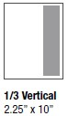  1/3rd  Page  Vert. | Stand out with this unique ad space! Tell your story with text and photos!  Size: 2.25” x 10” | $1,010
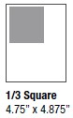  1/3rd  Page  Square | Be a square here and you’ll fit right in! Tell your story in this great space!  Size: 4.75” x 4.875” | $1,010
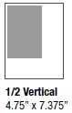
1/2  Page  Vert. | An impressive space for any business! Plenty of room for creativity!  Size: 4.75” x 7.375” | $1,575
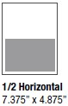  1/2  Page  Horiz. | Another equally impressive space! Keep the creativity flowing!  Size: 7.375” x 4.875” | $1,575
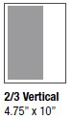  2/3  Page  Vert. | Think of the possibilities of this impressive layout! Draw great attention with your ad!  Size: 4.75” x 10” | $1,800
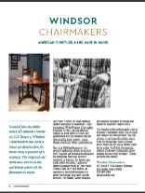  Full  Page  Advertorial | Tell your story in an engaging way by crafting your own article-style page with photos and text! Keeps the reader longer and tells them why you’re special!  Bleed Size: 8.625” x 11.125” | $1,975
  Full  Page | Make your biggest impact with a  full-page ad! An impressive statement about your business!  Trim Size: 8.375” x 10.875”  Bleed Size: 8.625” x 11.125”  No Bleed Size: 7.375” x 9.875” | $2,000

Additional Options:

- Business Directory Listing/Food & Accommodations Grids: FREE!
- Additional Business Directory Listing - $125 per Category
i.e. Bell the Cat listed under both Restaurants and Catering
- Enhanced Listing: 25-word business description - $100
Stand out with a detailed listing in the directory or food/accommodations grids
Add $100 for every additional 25 words
- Creative Ad Assistance - $200
Need help creating your ad? The Chamber does that!
- Calendar Listing: 50-word event description - $125

Important Deadlines:
- All Advertisements and Payment due Monday, January 4, 2027
- Calendar and Enhanced Listing submissions should be sent in text format (Word Doc or email) by Monday, Dec 14, 2026.

Important Details:

- All Ads MUST be submitted in .PDF format
- New Members in 2026 get a 15% discount on advertisements!
- The Chamber now offers members Creative Ad Assistance for an additional cost of $200. Please contact Scott to get started!
- Our guide is available any time on our website as a flipbook!
- Advertising is limited to Chamber Members only, but we welcome the opportunity to do business with you! Contact the Chamber or visit our website for membership information!
- All other information will be based on your current
Chamber Website listing; Members should review/update their information regularly and mark your calendars for submission deadlines!


Belfast Area Chamber of Commerce is proud to partner with
Down East Brand Studio again on this wonderful publication.

FOR MORE INFORMATION:
Please contact Scott at
ChamberOffice@BelfastMaine.org or call 207 338 5900
www.BelfastMaine.org

Belfast Area Chamber of Commerce | PO Box 58 | 33 Main St. Belfast, ME 04915

